**Excel Assignment 1**

1. What is Excel? Why do we use Excel?

Ans. Excel definition: a software program created by Microsoft that uses spreadsheets to organize numbers and data with formulas and functions. Excel analysis is ubiquitous around the world and used by businesses of all sizes to perform financial analysis.

The main use of Excel is:

* Data Entry
* Data Management
* Accounting
* Financial Analysis
* Charting and Graphing
* Programming
* Task management
* Financial Modelling

1. List all the versions of Microsoft excel. Compare excel software provided from multiple vendors.

Ans. Versions of Excel:

* Excel 365
* Excel 2019
* Excel 2016 and 365
* Excel 2013 (Windows)
* Excel 2011 (Mac)
* Excel 2010 (Windows)
* Excel 2008 (Mac)
* Excel 2007 (Windows)
* Excel 2004 (Mac)
* Excel 2003 (Windows)
* Older Windows versions (2002, 2000, 97, 95, 4.0, 3.0, 2.0)
* Older Mac versions (2001, 2000, 98, 5, 4, 3, 2, 1)
* OS/2 Versions (2.2, 2.3, 3)

1. How to create bar charts in excel, demonstrated with practical examples.

Ans.

To insert a bar chart in Microsoft Excel, open your Excel workbook and select your data. You can do this manually using your mouse, or you can select a cell in your range and press Ctrl+A to select the data automatically.

Once your data is selected, click Insert > Insert Column or Bar Chart.

Various column charts are available, but to insert a standard bar chart, click the “Clustered Chart” option. This chart is the first icon listed under the “2-D Column” section.

For Example: Sales data can be coverted into bar chart

Sales as per Product can be demonstrated by Bar chart,

A sample bar chart in Microsoft Excel, showing the number of sales for a number of electronic products, with the data range beside it 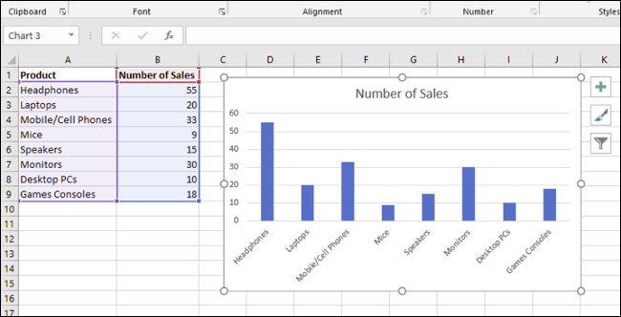

1. Create an analytics dashboard in python and present your findings.
2. How to connect Excel with the databases.

Ans.

1. To connect Excel to a database in SQL Database, open Excel and then create a new workbook or open an existing Excel workbook.
2. In the menu bar at the top of the page, select the Data tab, select Get Data, select From Azure, and then select From Azure SQL Database.
3. In the SQL Server database dialog box, type the Server name you want to connect to in the form <servername>.database.windows.net. For example, msftestserver.database.windows.net. Optionally, enter in the name of your database. Select OK to open the credentials window.
4. n the SQL Server database dialog box, select Database on the left side, and then enter in your User Name and Password for the server you want to connect to. Select Connect to open the Navigator.
5. In the Navigator, select the database you want to work with from the list, select the tables or views you want to work with (we chose vGetAllCategories), and then select Load to move the data from your database to your Excel spreadsheet.